AVDT Mentee Preparation – Quiz 3

Name the Structure

- Philtrum
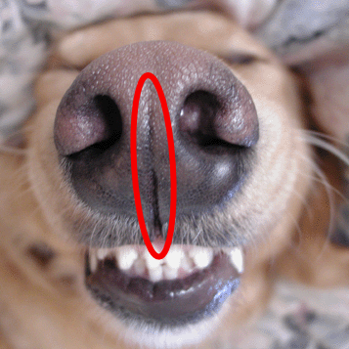

- Incisive Papillae
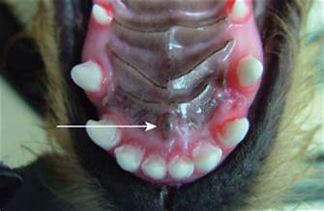

- Palatine Rugae (Name the folds present on the hard palate)
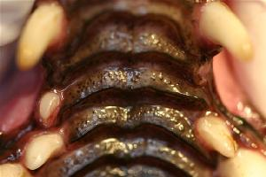

- Alar folds (Name the fold on the lateral aspect of the nose)
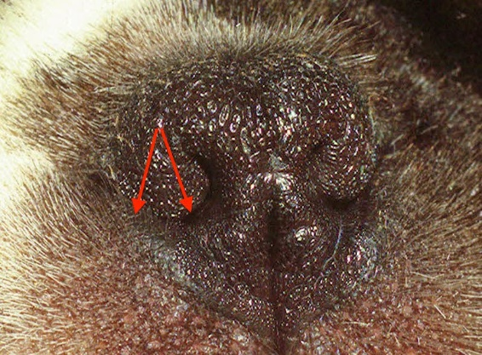

- Lingual frenulum
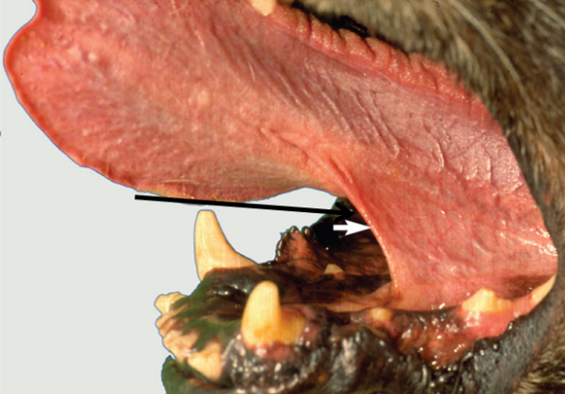

- Mucogingival line (The name given to the line at the end of the arrow)

- Vertical groove or bleeding groove (The term given to the “groove” in a feline’s canine tooth)

- Lingual molar gland (Name the structure lingual to the feline mandibular molar)
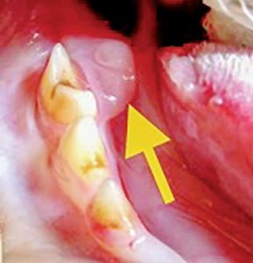

Label the Diagram Below

